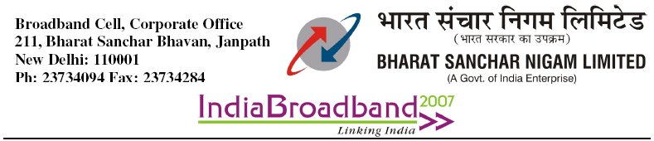
No: 64-17/09-Broadband Dt 03-06-09
To
All Heads of Circles/Metro Districts.

Sub: USO Fund subsidy for all Rural Broadband plans.

Kindly refer to the agreement signed with USOF for giving BB connections in rural exchanges on 20-01-09. In this connection two new USOF tariff plans Plan 99 & Plan150 were introduced from 03-02-2009.
Now the approval of the competent authority is hereby conveyed for getting subsidy for all broadband connections given in rural exchanges covered under USOF agreement irrespective of tariff plans. While submitting claims it may be ensured that no subsidy is claimed for connections given up to 03/02/2009 since USOF plans were introduced on 03/ 02/2009 only.

(M.S.T.Sundari)
AGM(BSP)
Copy to
- Dir (CFA), BSNL C.O., New Delhi for information please.

